About CMS Portal

Content Management System (CMS) is PropTiger's internal tool that is serves the purpose of handling all the data and its management for PropTiger as well as Makaan.com.
There are two principal sources of data for the CMS portal, through the IS(Information System) teama containing all the information related to primary and new sales whereas makaan too supplies data as the second source furnishing primary and secondary sales data.

Data from the IS team into the CMS is mainly concerened with details of new incoming as well as the existing ones projects such as :
- Scheduled launch date of the project.
- Associated builder(s) details.
- Expected date of completion of the project.
- Inventory(-ies) involved in the project and the supply thereof in a stipulated time period.
- Details involving the project configuration, amenities etc.

Likewise, makaan.com provides data for properties on sale or rented for accommodation etc. Via the CMS.

In brief the various functinalities provided by CMS may be covered as under but is not exclusive :
- Projects Management.
- Builder Management.
- Lisitng Management, i.e. details specific to a particular property flagged for sale or rent purpose.
- City Management.
- Suburb Management.
- Locality Management.
- Bulk update of projects.
- Broken Agent Management.
- Company Management.

CMS DB Schema

Objective: Creating a database schema to support new resale and rental business and maintaining versioning of data wherever needed.

Challenges:
- Enabling data versioning.
- Common schema to support resale and rental.
- Maintaining referential integrity of key data points.
- Minimising DB schema changes with ongoing business needs.

Key Definitions:
- CITY
- SUBURB: Comes directly under city in location hierarchy. Belongs to a city.
- LOCALITY: Leaf level of locality hierarchy. Belongs to a suburb.
- BUILDER
- PROJECT: Belongs to a builder(for now).
- PHASE: A project in certain cases is divided among phases. Pricing may vary along phases. Inventory is kept at phase level.
- TOWER: Project can have certain towers. Towers belongs to project and maps to phase with many to many relationship.
- OPTION: An option is a unique combination of all the parameters currently used to distinguish units in a project. OPTION belongs to a project and maps to phase with many to many relationship.
e.g.: A 2 BHK flat with a pooja room is one option. A 2 bhk flat without a pooja room is another.
- LISTING: A listing is a leaf level entity in the downward hierarchy of project. A unique combination of OPTION, PHASE, LISTING_TYPE and BROKER is a listing.
- LISTING_TYPE: Primary, resale and rental are the 3 possible listing types as of now.
- BROKER: Broker is a first level contact detail associated with a listing.

Approach:

Versioning: This is the general approach taken at places where we needed data versioning:
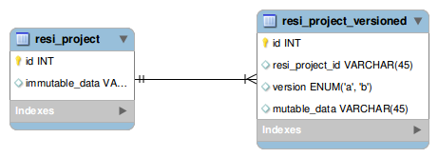
In order to reduce complexity, we are storing all the data in versioned table itself. Original table is there to hold the primary keys only. Website will read data at one specific ‘version’ all the time and rest of the versions will be used for various update/audit cycles and rollbacks(maybe).

Objects: We have defined certain entities which are key to our business as ‘objects’. As of now, we have 3 such objects and the count can increase in future:
- City
- Builder
- Project
Each of these objects will have their own hierarchy of sub objects.

Tower Project Phase Relationship: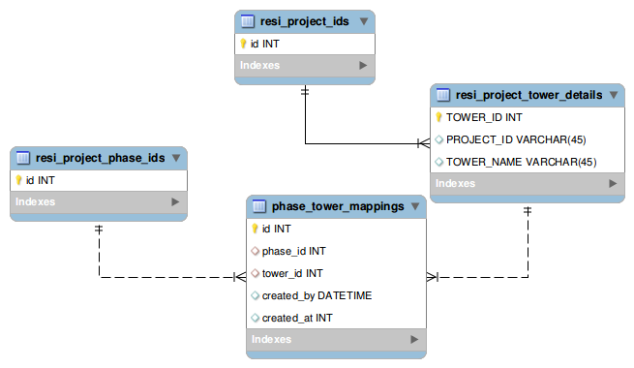

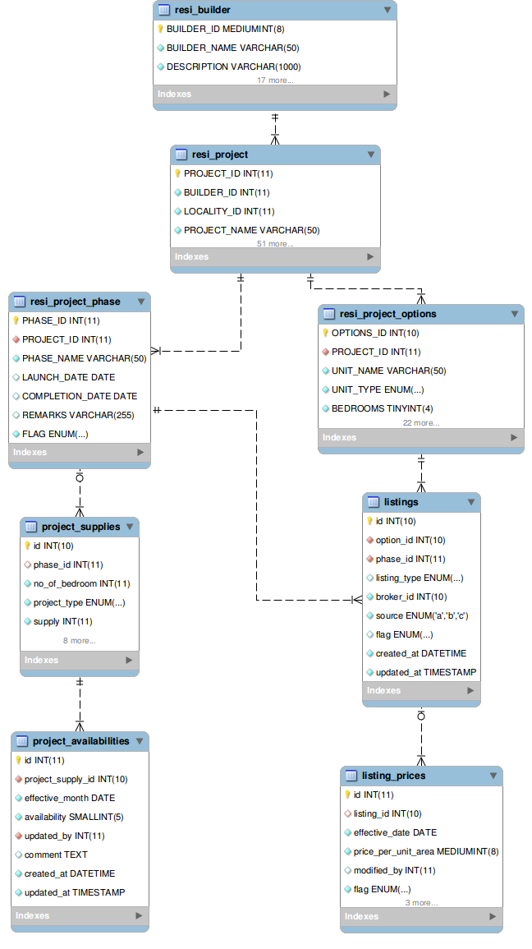

Storing Attributes Common Across Objects: There are certain attributes which are common across objects. One such example is SEO specific data. We are keeping such data in following manner: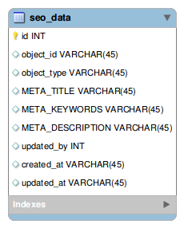
SEO data is very sparse across ids of an object. This makes it eligible for such abstraction.

Storing Sparse Data : There are certain fields which are very sparsely populated. Need for new fields can come any time. Instead of creating new columns for every such requirement, we are storing the data like this:
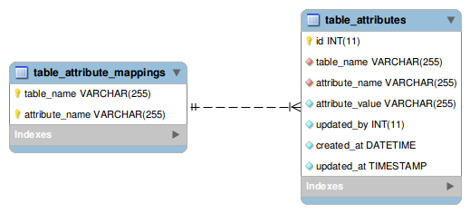
Mapping table is there to give us the control over the values being inserted in the table. This will not be exposed to the outside world.
Also, this table will regularly be monitored for attributes which are not so sparse. Such values can be moved into the main table if needed.

Fixed Length IDs: Objects of various types will have ids of fixed length. This will help team in recognising the ids easily.
- CITY_ID: starting from 1
- SUBURB_ID: 5 digit starting from 10001
- LOCALITY_ID: 5 digit starting from 50001
- BUILDER_ID: 6 digit starting from 100001
- PROJECT_ID: 6 digit starting from 500001
- PHASE_ID: 7 digit starting from 1000001
- OPTION_ID: 7 digit starting from 5000001
- SELLER_ID: 8 digit starting from 10000001
- LISTING_ID: 8 digit starting from 50000001

Major Shifts From Last Schema:
- Data versioning has been introduced for ‘project’, ‘phase’, ‘price’ and ‘inventory’ data.
- Concept of ‘No Phase’ with ‘null’ PHASE_ID has been abolished. It’s mandatory to create a phase before adding price/inventory data.
- Tower now has many to many mapping with phase. One tower can now belong to more than one phases.
- We will be storing mysql user detail in audit(trigger) tables.
- Sparsely populated data to be stored in common table.
- Trigger definitions has been enhanced in order to prevent redundant logging.
- video data of all tables moved to the video_links table
- Near places information added. near_place_types table store types of near places and locality_near_places table stores information of all types of near places within a city with latitude and longitude data.

To be Done in Future:

Must Do:
- Image/video data to be moved to media service. Corresponding columns to be removed.
- PROJECT to BUILDER mapping to be changed to one to many.
- ENTITY and URL fields in resi_builder to be made unique.
- PROJECT_STAGE_ID and PROJECT_PHASE_ID must be removed from resi_project. These are already there in project_stage_history.

Should Do:
- Concept of ‘PROJECT_PHASE’ and ‘PROJECT_STAGE’ needs to be reviewed.
- ‘PROJECT_TYPE_ID’ field from resi_project table needs to be moved to another table. Types like ‘VILLA APARTMENT’ needs to be removed.
- Common user table so that updated_by field can be referenced.
- 'LAUNCH_DATE' and 'COMPLETION_DATE' should be removed from resi_project. It's already there in phase table against 'No Phase'.

Changes in Version 2:
- Supply/Inventory is now being stored at listing level. ER Diagram would now look like:
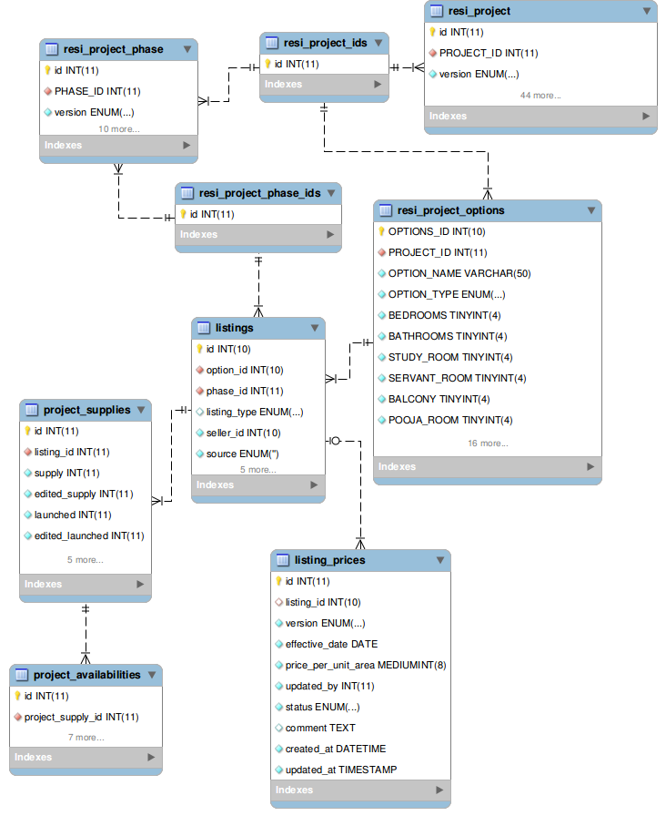
- All tables/columns storing image urls have been removed. This info will be their in media service.
- Here is the list of all the tables in ‘project’ database with a small description(TABLE COMMENT) of what’s stored in it.

Other Pricing schema
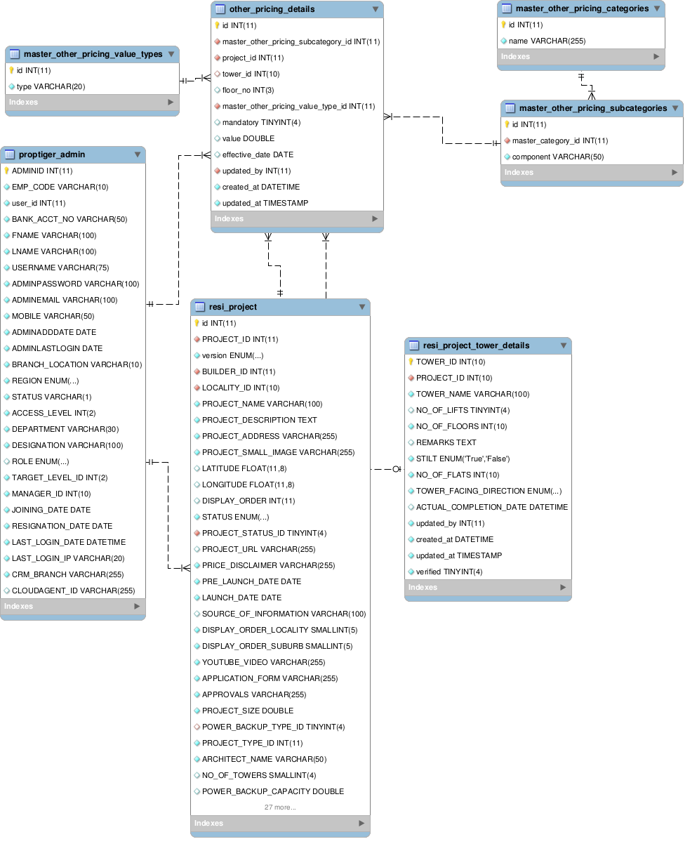

SNo | TABLE_NAME | TABLE_COMMENT
1 | BROKER_LIST | List of brokers created by CMS users. Brokers are outside co
2 | CallDetails | Stores call details of the calls made through ozonetel.
3 | CallProject | Lists projects for which info was gathered on a call.
4 | RESALE_INVENTORY | Resale data added by CMS team based on contacts.
5 | amenities_master | Master table containing all amenities. All amenities belongi
6 | bank_list | Master list of all banks.
7 | broker_project_mapping | Maps brokers to a project. Resale related.
8 | builder_contact_info | Stores contact details for a builder. Can have many entries
9 | city | Master city info.
10 | comments_history | Stores comments on a project by various teams
11 | country | Master table for countries.
12 | listing_prices | Stores historical price info for a listing.
13 | listings | Defines the entity listing. Have distinct values for option-
14 | locality | Master table for locality.
15 | locality_image | stores images related to locality
16 | name_change_log | Lists name change history for city
17 | phase_tower_mappings | Stores mapping b/w phase and tower. Many to many mapping.
18 | project_assignment | Stores history of project assignment to calling team.
19 | project_availabilities | Stores historical inventory informatiion against supply.
20 | project_banks | Maps projects to banks.
21 | project_offers | Stores offers for project.
22 | project_plan_images | Images for project plan.
23 | project_secondary_price | Stores secondary price info. Updated by CMS team.
24 | project_stage_history | stores history of movement of project between different stag
25 | project_status_master | stores all possible values of project status
26 | project_supplies | stores supply against a listing.
27 | proptiger_admin | cms user list
28 | proptiger_admin_city | cms user to city mapping.
29 | redirect_url_map | stores curtom url redirection info
30 | resi_builder | stores builder information
31 | resi_floor_plans | stores floor plan images
32 | resi_proj_expected_completion | stores history of promised completion dates
33 | resi_proj_options_room_size | room size of different room types in an option.
34 | resi_project | master table for project information
35 | resi_project_amenities | list of amenities in a project
36 | resi_project_ids | Stores all project ids
37 | resi_project_options | stores all options of a project
38 | resi_project_phase | master table for all project phases.
39 | resi_project_phase_ids | stores project phase ids
40 | resi_project_tower_details | master table for project tower details
41 | resi_project_type | master table for all possible combination of project types.
42 | resi_sourceofinformation | master table for source of information
43 | room_category | master table for room categories.
44 | suburb | master table for suburbs
45 | table_attribute_mappings | master table holding all possible attributes of a table for
46 | table_attributes | common table to store sparse attributes
47 | townships | master table for townsips
48 | updation_cycle | master table for updation cycle

New Tables -

1 | is_metrics | table storing summary of project description available at projects
2 | locality_near_places | stores basic amenities available near localities
3 | master_booking_statuses | master table to stores all booking statuses
4 | master_power_backup_types | stores all possible power backup option types
5 | master_project_phases | master table storing all project phases
6 | master_project_stages | master table storing all project stages
7 | near_place_types | master table storing basic amenities types near localities
8 | project_aliases
9 | project_builder_contact_mappings
10 | project_migration | stores data related to project migration to specific version
11 | RESALE_INVENTORY | Resale data added by CMS team based on contacts.
12 | project_assignment_rules
13 | rule_agent_mappings | holding agent entries for project assignment rules
14 | rule_locality_mappings | holding locality entries for project assignment rules
15 | rule_project_mappings | holding project entries for project assignment rules
16 | schema_migrations
17 | seo_data | stores seo_data for all objects
18 | video_links | stores video links for all tables entries, has many to many relationship
19 | d_inventory_prices | table for storing denormalised data for b2b product
20 | d_inventory_prices_tmp | tmp table for storing denormalised data for b2b product

